# [As ‘SVU’ Makes History, Mariska Hargitay Makes Olivia Benson’s Mission Her Own](https://www.nytimes.com/2019/09/25/arts/television/mariska-hargitay-law-and-order-svu.html)

This week “Law & Order: SVU” becomes the longest-running drama in prime-time history. But in some ways, the culture is just catching up to the series and its crusading star.

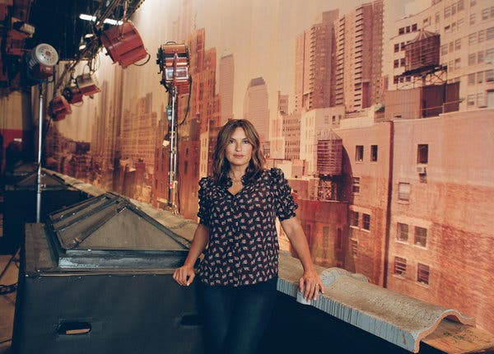



On Thursday, Mariska Hargitay and “Law & Order: SVU” begin the show’s record-breaking 21st season. Starring as Olivia Benson has transformed Hargitay from “actor to activist,” she said.Credit...Clement Pascal for The New York Times

**By Ilana Kaplan**

* Published Sept. 25, 2019Updated Sept. 26, 2019
  + *20*

When Mariska Hargitay isn’t grilling perps in gloomy interrogation rooms, she spends most of her time in a real-life Pinterest board.

Just down the hall from the “Law and Order: SVU” squad room set, in the show’s new Chelsea Piers production hub, is Hargitay’s “oasis” — a hybrid office-dressing room full of inspirational “visual aids.” Her very first cover story, in Time Out New York, is framed above a [millennial pink](https://www.thecut.com/2017/03/why-millennial-pink-refuses-to-go-away.html) couch. Nearby is an array of photos — subjects include her husband, the actor Peter Hermann; her children; her “SVU” co-star Ice-T; and, in a life-size poster, Hargitay and her former “SVU” partner, Christopher Meloni. Fittingly for a feminist hero, another wall is devoted to Wonder Woman memorabilia and an end table is covered in Ruth Bader Ginsburg-themed books and tchotchkes.

Olivia Benson would be proud. Over 20 seasons, Hargitay’s empathetic TV detective has become something of a pop culture icon for her all-consuming drive for justice for the “special victims” she works with, generally female survivors of sexual assault.

In recent years “SVU” has come into new relevancy as the #MeToo movement has spurred a broader reckoning with the prevalence and consequences of sexual harassment and assault.

ADVERTISEMENT

[Continue reading the main story](https://www.nytimes.com/2019/09/25/arts/television/mariska-hargitay-law-and-order-svu.html#after-story-ad-1)

For Hargitay it’s been a long time coming.

“I am appalled and jubilant at this moment,” she said. “I’m horrified, and I’m doing a happy dance that this is what is dominating the media because I say thank God, finally, the collective culture is focusing on this. Because that is the only way, *the only way* that we’re going to eradicate it.”

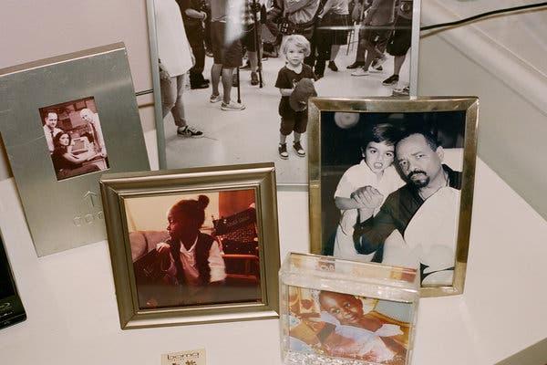

Image

Hargitay’s hybrid office-dressing room is an “oasis,” she said, full of photos and other “visual aids.”Credit...Clement Pascal for The New York Times



Image



“We needed this character who relentlessly fights and advocates for women and for survivors,” said Hargitay, here on “SVU” with Kelli Giddish and Ice-T.Credit...Michael Parmelee/NBC

On Thursday, “SVU” begins its 21st season, which will make it the longest-running prime-time drama in American TV history (surpassing its parent show, “Law & Order,” and the western “Gunsmoke”) and make Olivia Benson TV’s longest-running prime-time drama character. (“The Simpsons” holds most prime-time longevity records at this point.)

Neither the series nor the actress plans to shut down the unit anytime soon. That’s partly because “SVU” still draws respectable ratings for NBC, but also because what started as a job for Hargitay has become her life’s work.

ADVERTISEMENT

[Continue reading the main story](https://www.nytimes.com/2019/09/25/arts/television/mariska-hargitay-law-and-order-svu.html#after-story-ad-2)

Since taking on Benson in 1999, Hargitay, 55, has also spent much of her life offscreen working for victims of sexual assault. She trained to become a rape crisis counselor, and in 2004 she founded the Joyful Heart Foundation, a nonprofit that helps survivors of sexual assault, domestic violence and child abuse. On Tuesday night she accepted an Emmy for [“I Am Evidence,”](https://www.youtube.com/watch?v=nXZJWfJhdn4&feature=youtu.be&t=12918) the HBO documentary she produced and starred in that investigates how police handle sexual assault cases in the United States.

“I’m more engaged now than ever, and I was *pretty* engaged when I started this,” she said. “It turned me from sort of actor to activist.”

While she shares Benson’s obsessions, in person Hargitay is a near opposite. Playful and affable where her alter ego is taciturn and matter-of-fact, she also veers sharply from Benson’s grayscale wardrobe, surrounding herself in color. Settled in a plush, plum armchair with Sally Jessy Raphael-red reading glasses perched atop her head, she radiated bubbly energy and moved her hands constantly in conversation. “I’m a gesticulator,” she warned.

The daughter of the actress Jayne Mansfield and the bodybuilder-actor Mickey Hargitay, she studied acting at U.C.L.A. and landed her first role in the 1985 comedy-horror film “Ghoulies.” She starred on her first TV series one year later, the crime drama “Downtown,” and went on to appear on shows like “Falcon Crest,” “Can’t Hurry Love” and “ER.”

## **Editors’ Picks**

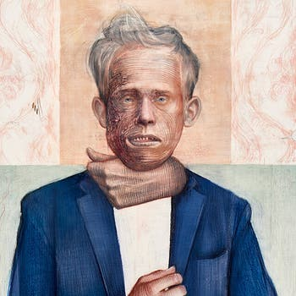

### [How ‘The Talented Mr. Ripley’ Foretold Our Era of Grifting](https://www.nytimes.com/2020/11/12/t-magazine/mr-ripley.html?action=click&algo=random_desk_filter&block=editors_picks_recirc&fellback=false&imp_id=74963301&impression_id=ca8d66a0-2c37-11eb-83ff-e529a44de30a&index=0&pgtype=Article&region=ccolumn&req_id=106576737&surface=home-featured&action=click&module=editorContent&pgtype=Article&region=CompanionColumn&contentCollection=Trending)

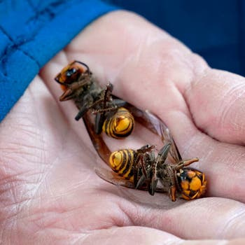

### [Scientists Destroyed a Nest of Murder Hornets. Here’s What They Learned.](https://www.nytimes.com/2020/11/13/us/murder-hornets-us.html?action=click&algo=random_desk_filter&block=editors_picks_recirc&fellback=false&imp_id=379028211&impression_id=ca8d66a1-2c37-11eb-83ff-e529a44de30a&index=1&pgtype=Article&region=ccolumn&req_id=106576737&surface=home-featured&action=click&module=editorContent&pgtype=Article&region=CompanionColumn&contentCollection=Trending)



### [Have a Look at the Fabled Honey Forest](https://www.nytimes.com/2020/11/16/travel/turkey-honey-forest-bees.html?action=click&algo=random_desk_filter&block=editors_picks_recirc&fellback=false&imp_id=802275244&impression_id=ca8d66a2-2c37-11eb-83ff-e529a44de30a&index=2&pgtype=Article&region=ccolumn&req_id=106576737&surface=home-featured&action=click&module=editorContent&pgtype=Article&region=CompanionColumn&contentCollection=Trending)

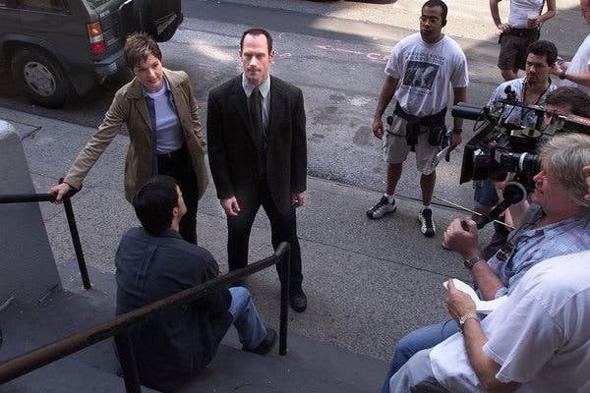

Image



Hargitay and Christopher Meloni played partners on “SVU” from the first season, in 1999, until Meloni left the show in 2011.Credit...Nicole Bengiveno/The New York Times

But everything changed in 1999 when she landed the role of Benson on “SVU,” and she hasn’t looked back since. “I fell so in love with her and so in love with the idea of this show, as progressive as it was at the time, and telling these kinds of stories,” she said.

The show brought her awards, a star on the Hollywood Walk of Fame and a spot in the cultural imagination. Taylor Swift, who famously named one of her cats Olivia Benson, recruited Hargitay for the video for her song [“Bad Blood”](https://www.youtube.com/watch?v=QcIy9NiNbmo) in 2015. More recently, Hargitay starred with Ice-T in a “SVU”-themed “Game of Thrones” parody on [“Saturday Night Live.”](https://www.youtube.com/watch?v=r8EF3X8EI2o&feature=youtu.be&t=118)

More meaningfully, the character at times has been a source of comfort for real-life victims and survivors. In the 2016 book [“We Believe You: Survivors of Campus Sexual Assault Speak Out,”](https://www.indiebound.org/book/9781627795333) a writer discussed how “[Olivia Benson](https://www.bitchmedia.org/article/olivia-benson-believes-me) shattered the self-blame and uncertainty I had endured for years.”

Hargitay said that viewers often approach her to share their personal experiences with sexual assault. The topic, and that of Benson’s broader impact with women and survivors of abuse, makes her emotional.

**THE MORNING:** *Make sense of the day’s news and ideas. David Leonhardt and Times journalists guide you through what’s happening — and why it matters.*

**Sign Up**

“It became very apparent to me early how much, culturally, we needed this character who relentlessly fights and advocates for women and forsurvivors, and who does it with compassion,” she said through tears. “Somebody who is unequivocally committed to righting wrongs, who believes survivors, who’s aware of the healing in it.”

At her foundation’s “Being Believed” panel in May, where Hargitay spoke alongside the author Roxane Gay and the prosecutor Kym Worthy of Wayne County, Mich., some women disclosed their assaults for the first time. She has also made the widespread [rape-kit backlog at police departments](https://www.nytimes.com/2014/11/13/nyregion/new-york-initiative-to-help-other-cities-clear-rape-kit-backlogs.html) a personal focus — her documentary “I Am Evidence” investigates that issue in particular.

“If somebody’s rape kit is not tested, what’s that saying?” she said. “That says you don’t matter, and *no one* should experience not mattering.”

Dick Wolf, the “Law & Order” mastermind, calls Hargitay “the mother of the #MeToo movement.”



Image



Hargitay veers sharply from Benson’s taciturn demeanor and grayscale wardrobe, surrounding herself in color.Credit...Clement Pascal for The New York Times

“She has clearly been affected by her role as Detective Benson, and she has turned that into a mission to make a difference,” he wrote in an email.

Over 20 seasons, “SVU” has remained true to its procedural roots. It brings in the occasional celebrity to spice up its cases of the week — Bradley Cooper, Carol Burnett, Robin Williams, Serena Williams — but otherwise it evolves mostly in the headlines it rips and the investigative tactics it incorporates, like the latest forms of trauma interviewing. In recent years it has flirted more with continuing story lines as it has gone deeper into Benson’s and other characters’ personal lives.

In addition to its own two-decade run, “Law & Order” generated six spinoff series. “SVU” is the only one left standing. Last season it drew more than 7 million viewers on average, which was enough to keep it in the Top 50 of [all broadcast series](https://www.hollywoodreporter.com/live-feed/live-7-ratings-broadcast-tv-series-2018-19-1217293). (It ranked within the Top 30 among the coveted viewers aged 18-49.) According to NBC, the show also thrives on Hulu, where it draws a much younger audience.

Producers credit Hargitay with the show’s longevity, pointing to both the enduring appeal of the character and the actress’s steadying presence on the set.

“The reason the show is 21 years in is Mariska,” the showrunner Warren Leight said. “The No. 1 on the call sheet defines your show. If it’s toxic, it starts there, and if it’s open, warm and generous, it’s a different kind of show.”



Image



Before “SVU” ends, Hargitay wants Olivia Benson and Meloni’s Elliot Stabler to reunite.Credit...Virginia Sherwood/NBC

Hargitay never imagined she would be playing Olivia Benson for over 20 years, but she remains committed to surprising the “SVU” faithful as well as herself. “This is Season 21, baby — there’s never been a Season 21,” she said. “We’ve got to do it differently.” (She was tight-lipped about details, aside from mentioning that Ian McShane would make a guest appearance.)

NBC hasn’t yet renewed “SVU” for a Season 22. But with the show’s move several years ago from New Jersey to Chelsea making it easier for Hargitay to coordinate her family schedule — her children go to school in Manhattan — she isn’t thinking about the end, she said.

When she does decide to call it quits, though, she will have at least one thing to check off first: a reunion between Benson and Meloni’s Elliot Stabler.

“It just has to be that way, doesn’t it?” she said. “I started it with him, and I want to finish it with him.” Meloni [has said](https://twitter.com/Chris_Meloni/status/1072685574077726720) that he has no plans to return to “SVU,” although the actors remain close; last week Hargitay posted [photos on Instagram](https://www.instagram.com/p/B2dgBnVn9Oj/) of herself and Meloni, whom she compares to an “ex-husband.”

But should Meloni return, don’t expect the romance plotline viewers clamored for throughout their run as partners. “I think that was the beauty of it — we just always knew that could never happen because the tension, and the love, was the magic,” Hargitay said.

As the conversation came to a close, her gaze fell upon another photo on her office wall, a black-and-white shot of a woman running on a beach. It was of Hilary Swank, a close friend, taken from a Vanity Fair cover shoot.

“When I saw that picture, I said, ‘Hilary, I need this,’” Hargitay said. “Because that’s a marathon. That’s what I’ve been on for 21 years.” And she doesn’t plan to stop running anytime soon.